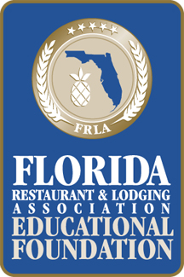
18th Annual ProStart

Culinary Team Competitions

Rosen Plaza Hotel

Grand Ballroom

AGENDA

Saturday, March 3, 2018
8:30 AM – 6 PM | Johnson & Wales University Culinary Competition
9 AM – 5:30 PM | The Art Institutes Management Competition
9:15 AM – 3 PM | Keiser University Edible Centerpiece Competition
9 AM – 6 PM | Education & Business Expo

Sunday, March 4, 2018
6:30 AM – 3 PM | Johnson & Wales University Culinary Competition
8 AM - 3 PM | Education & Business Expo
9:00 AM – 3:00 PM | The Art Institutes MANAGEMENT COMPETITION
9:30 AM | Chef’s Warehouse Raffle (Immediately before the Waiters Relay Competition)
10 AM – 1 PM | The Coca-Cola Waiters Relay Competition
6:30 PM– 9:00 PM | Salute to Excellence Awards Dinner at Rosen Plaza Hotel, Grand Ballroom

Times listed above are subject to change due to participant changes

